**BIDDS Debrief Card v0.1**

1. Download FDR and DRD Files from DTC
   1. BIDDS v4.1 supports ODD
   2. Also, can download using JMPS>B52>FDR SPI>Save FDR
2. Save FDR File as Text File using BIDDS
   1. Copy DRD Files to BIDDS Folder prior to opening FDR File
      1. Only need to do if new DRD files on DTC
   2. Open B52FDR File (need to change file type to All in File picker to select)
   3. Save FDR File to Text File

1. Open debrief.exe

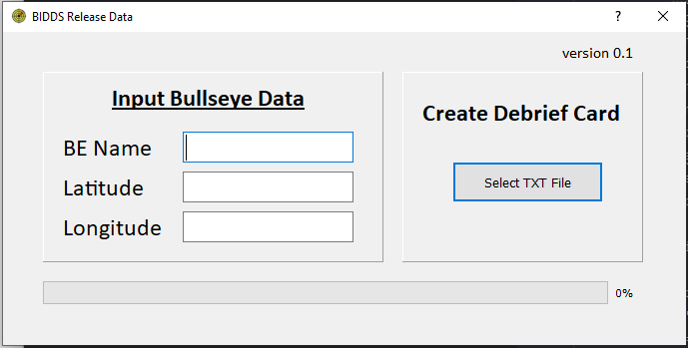

* 1. Set Bullseye Data
     1. Format H DD MM.MMMM
  2. Click Select Text File and find text file created in Step 2
  3. 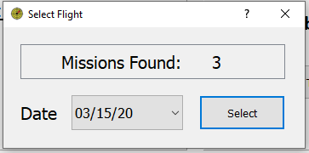Select Flight in popup

* 1. Click Select and Excel will display all release data

1. Excel
   1. 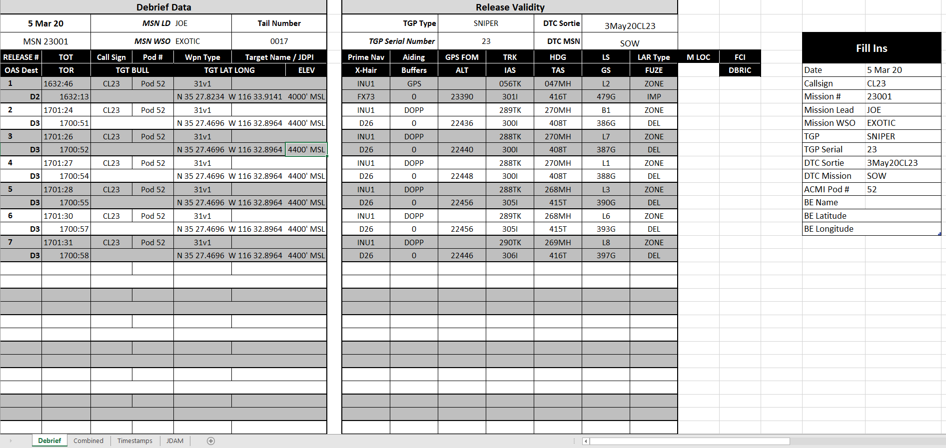Debrief Sheet

Fill In table at the right to populate remaining data in the card

* 1. Other Sheets
     1. Combined (This is where all the debrief data pulls from)
     2. Timestamps (Shows all Mission Events from FDR File)
        1. JMPS GPS File is WIP
     3. Weapon Tabs
        1. Show release events and all data from FDR File